Problems for First-Fit, Best-Fit, and Worst-Fit Memory Allocation Strategies

1. First-Fit Problem
Scenario:
Available memory blocks (in KB):
Block Sizes: 100, 500, 200, 300, 600
Processes to be allocated (in KB):
Process Sizes: 212, 417, 112, 426
Steps:
- 212 KB: Fits in the first block of size 500 KB. Remaining: 500 - 212 = 288 KB.
100, 288, 200, 300, 600
- 417 KB: Fits in the first block of size 600 KB. Remaining: 600 - 417 = 183 KB.
100, 288, 200, 300, 183
- 112 KB: Fits in the first block of size 288 KB. Remaining: 288 - 112 = 176 KB.
100, 176, 200, 300, 183
- 426 KB: Cannot fit in any block.
Result:
- Processes allocated: 212 KB, 417 KB, 112 KB
- Process not allocated: 426 KB
- External fragmentation: 100 KB (first block) + 176 KB (second block) + 183 KB (last block).

2. Best-Fit Problem
Scenario:
Available memory blocks (in KB):
Block Sizes: 100, 500, 200, 300, 600
Processes to be allocated (in KB):
Process Sizes: 212, 417, 112, 426
Steps:
212 KB: Fits in the block of size 300 KB (smallest block that fits). Remaining: 300 - 212 = 88 KB. 100, 500, 200,88, 600
- 417 KB: Fits in the block of size 500 KB. Remaining: 500 - 417 = 83 KB.
- 112 KB: Fits in the block of size 200 KB. Remaining: 200 - 112 = 88 KB.
- 426 KB: Fits in the block of size 600 KB. Remaining: 600 - 426 = 174 KB.
Result:
- All processes are allocated.
- External fragmentation: 100 KB (first block) + 88 KB (second block) + 83 KB (third block).

3. Worst-Fit Problem
Scenario:
Available memory blocks (in KB):
Block Sizes: 100, 500, 200, 300, 600
Processes to be allocated (in KB):
Process Sizes: 212, 417, 112, 426
Steps:
- 212 KB: Fits in the largest block, 600 KB. Remaining: 600 - 212 = 388 KB.
- 417 KB: Fits in the largest remaining block, 500 KB. Remaining: 500 - 417 = 83 KB.
- 112 KB: Fits in the largest remaining block, 388 KB. Remaining: 388 - 112 = 276 KB.
- 426 KB: Cannot fit in any block.
Result:
- Processes allocated: 212 KB, 417 KB, 112 KB
- Process not allocated: 426 KB
- External fragmentation: 100 KB (first block) + 83 KB (second block) + 276 KB (last block).

Key Observations:
- First-Fit: Simple but may leave gaps scattered in memory.
- Best-Fit: Minimizes leftover space but may create smaller, unusable fragments.
- Worst-Fit: Leaves larger fragments but may waste space when processes don't fit into smaller blocks.

1 | Formulate how long a paged memory reference takes if memory reference takes 200 nanoseconds .Assume a paging system with page table stored in memory.  In a paging system where the page table is stored in main memory and no TLB is used, each memory reference requires two memory accesses:  - Accessing the page table → 200 nanoseconds  - Accessing the actual memory word → 200 nanoseconds  Total paged memory reference time  $$\text{Total time}=200\text{ ns}+200\text{ ns}=\boxed{400\text{ nanoseconds}}$$  A paged memory reference takes 400 nanoseconds.
2 | Consider a logical address space of 128 pages, with 512 words per page, mapped onto a physical memory of 64 frames.  Answer the following:  a. How many bits are there in the logical address?  b. How many bits are there in the physical address?  Solution  Given  - Number of pages = 128  - Page size = 512 words  - Number of frames = 64  - Frame size = same as page size = 512 words  (a) Logical Address Size  A logical address consists of:  - Page number  - Offset (word number within the page)  Page number bits  - 128 pages  - $128=2^{7}$  - Page number requires 7 bits  Offset bits  - Page size = 512 words  - $512=2^{9}$  - Offset requires 9 bits  Total logical address bits  $$7+9=\boxed{16\text{ bits}}$$  (b) Physical Address Size  A physical address consists of:  - Frame number  - Offset  Frame number bits  - 64 frames  - $64=2^{6}$  - Frame number requires 6 bits  Offset bits  - Frame size = 512 words  - Offset = 9 bits  Total physical address bits  $$6+9=\boxed{15\text{ bits}}$$  - Logical address size = 16 bits  - Physical address size = 15 bits
3 | In the working set model, consider the following page reference string:  3 5 2 6 8 8 8 8 6 2 5 3 4 7 2 3 4 7 7 7 4 7 4 7 7 2 4 3 4  If Δ = 10, determine the working set at time t₁.  Step 1: Understand the Working Set Model  The working set at time t₁ with window size Δ is defined as:  The set of pages referenced during the last Δ page references up to and including time t₁.  Here:  - Δ = 10  - We must look at the last 10 page references before time t₁.  Step 2: Identify the Last Δ = 10 References  The last 10 references up to time t₁ are references 14 to 23:  7, 2, 3, 4, 7, 7, 7, 4, 7, 4  Step 3: Find the Working Set  The working set includes only the unique pages in the Δ window.  From:  7, 2, 3, 4, 7, 7, 7, 4, 7, 4  The distinct pages are:  {2, 3, 4, 7}  Working set at time t₁ (Δ = 10):  $$\boxed{\left\{2 , 3 , 4 , 7\right\}}$$
4 | A file of size 120 KB is stored on a disk with a block size of 2 KB.  a) How many blocks are required to store the file?  An index block can store 512 pointers. If the block size is 2 KB, find the maximum file size that can be supported using indexed allocation.  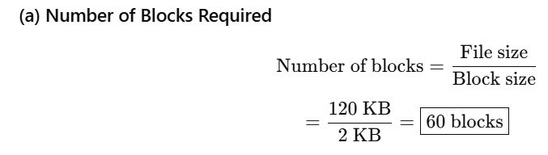  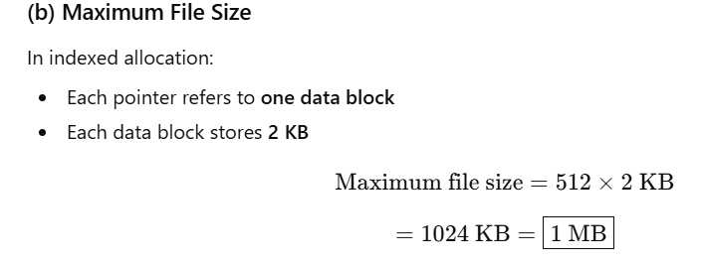  • Number of blocks required = 60 blocks  • Maximum file size = 1024 KB (1 MB)

